Atitit appcan debug

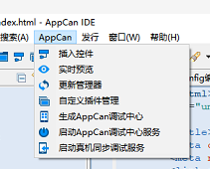

App debugf center install to cp ...

And pc boot debug center service...

Cp debug center inpout server ip adddr.....then conn...

Cyidon jinjyi debug serverice ..

